MKTG 2150-002

Introduction to Marketing

**Assignment Part 2 – Team Project**

**MARKETING MAKEOVER**

**Marketing Strategy Brief**

Ryan Gosling

Submitted by:

**ORIGAMI**

|  |  |
| --- | --- |
| Tyler Rop | 201520315 |
| Aislinn Grant | 201440428 |
| Vanessa Tran | 201494436 |
| Miguel Monzon | 201403903 |

Submitted to:

David McCallum

Bissett School of Business

Mount Royal University

01/04/2013

**Table of Contents**

1. Introduction p. 3
2. Customer Profile p. 3
3. Product SWOT p. 8
4. Perceptual Map p. 9
5. Pricing p. 11
6. Packaging Re-Design p. 11
7. Distribution p. 15
8. Promotion p. 15
9. References p. 17

**Brief Summary of Team Responsibilities for this Assignment**

|  |  |
| --- | --- |
| **Student Name** | **Student Responsibility** |
| **Tyler** | Updated Customer Profile, designed and created all branding (ORIGAMI dog logo, ORIGAMI text logo, print advertisement, billboard advertisement, Instagram advertisement, Facebook page), photography, product packaging (idea, design, creation). Compiled and edited the final document. |
| **Aislinn** | Created the Product SWOT, assisted in the development of the print advertisement, Facebook page, billboard advertisement, and the origami poster. Also edited the final document. |
| **Vanessa** | Wrote and developed the Perceptual Map and Pricing Strategy. |
| **Miguel** | Researched for and wrote Promotion and distribution strategy, presentation. |

**Introduction**

Using a target consumer profile based off of the Canadian celebrity Ryan Gosling, we have developed a product prototype for selling Orijen dog food to him and to people that share similar characteristics. This document outlines all of the consumer characteristics that Gosling has, then it moves into our product recommendation and analysis for what type of dog food that we believe would be best to sell to Gosling and other consumers similar to him. Next, there is a Strength, Weakness, Opportunity, and Threat (SWOT) Analysis which outlines all of these aspects in regards to our product Orijen dog food. After the SWOT is our Perceptual Map, which was used to distinguish how Orijen dog food compares to its competitors in the marketplace. Next is the complete re-design of the packaging for the product, which was designed based off of our research in regards to the parent brand Orijen, the SWOT Analysis, and the Perceptual Map. The Distribution Strategy is then used to describe how we will sell the product to consumers. Last is the Promotion Strategy that has been designed to maximize the engagement of customers and marketplace penetration.

**Customer Profile**

GEOGRAPHIC, DEMOGRAPHIC & PSYCHOGRAPHIC CHARACTERISTICS:

**Who are they?**

* **Geographic characteristics**

Ryan Gosling was born in Canada in London, Ontario in 1980 (Hopwood). He moved to Cornwall, Ontario with his family when he was young. He was homeschooled until he attended high school in Cornwall before the family relocated to Burlington, Ontario. Once he turned 17, he moved to Los Angeles for a role in Young Hercules (Ryan Gosling Biography - Facts, Birthday, Life Story - Biography.com). Currently Gosling has moved to New York City where his is often seen walking with his dog George (Jung, 2011).

* **Demographic characteristics**

Ryan Gosling is a 32-year-old actor, and is currently rumoured to be dating actress Eva Mendes (Ryan Gosling, Eva Mendes: All About Their Romance : People.com, 2013 ). His net worth in 2011 was $50 million, which he began accumulating when he was cast as a member of the Mickey Mouse Club from 1993 to 1995 (Ryan Gosling Net Worth | Celebrity Net Worth). He was homeschooled by his mother in Cornwall, Ontario before he attended the Cornwall Collegiate and Vocational High School. It was here that he became familiar with Drama and Fine Arts (Hopwood). When his family moved to Burlington, Ontario he attended Lester B. Pearson High School (Hopwood). His family is of English descent, and reports have shown that Gosling, Avril Lavigne, and Justin Bieber are all distantly related as far back as early Quebec settlers (Agency, 2012). Gosling has more than 960, 600 Twitter followers (Ryan Gosling (RyanGosling) on Twitter) and over 230,000 Facebook likes (Facebook - Ryan Gosling).

* **Psychographic characteristics**

Gosling was an interesting child, getting in so much trouble as a young one that his mother quit her job to home school him (Lawrence, 2008). He seems almost intent on creating a peculiar reputation for himself, made even more obvious by the sex doll named “Bianca” dressed up and gazing out his upstairs window during an interview in 2008 (Lawrence, 2008). Gosling often plays emotionally distant characters, especially in movies like 2004’s “The Notebook” and more recently 2011’s “Drive” - his first action movie and yet he still played a quiet role (Hopwood). He often expresses becoming sick of himself, and worries about being overexposed to the public (Hopwood). Though it may be hard to imagine him as modest, he often expresses how grateful he is for the opportunities he has been given (Chiarella, 2011). These opportunities have allowed him to become active with several different charities including Invisible Children, SickKids Foundation, and of course, PETA (Ryan Gosling's Charity Work, Events and Causes | Look To The Stars).

Ryan Gosling also has an interest in PETA, this is most likely due to his absolute adoration for his dog George. He is even quoted as saying that his dog is “much more interesting than him”, and that he would rather talk about George (Jones, 2013). He also told the interviewer that his dog was the “greatest love of his life” (Jones, 2013).

Unexpectedly, Gosling has an obsession with the supernatural. He made a creepy diorama for interviewer Tom Chiarella during their interview in 2011 and also used his interest for all things eerie in his music career (Chiarella, 2011). He started ‘Dead Man’s Bones’ with best friend Zach Shields, and released their first album “Never Let A Lack of Talent Get You Down” in 2009 (Phillips, Amy, 2009).

* How price sensitive are they? Why do you believe this?

Ryan Gosling showed his frugal side in an interview with Jay Leno when he discussed how he liked wearing his suit that he got for free, even though he has worn it already. He spoke of how this is unusual in show business, saying that most people do not wear the same thing twice but he likes the suit so much that he did not care (Wilson, 2011). In an interview with Ellen DeGeneres, Ryan Gosling spoke about the “swag room” at the Grammy Awards and how he does not like getting free items from companies who want his picture (Gosling, Ryan Gosling's Big Gift, 2011). Though it seems as though the star may not be a big spender, when it comes to George, his 11-year-old canine companion, there is no length to which he would not go to. The star even has special paper work that allows the dog to travel with him anywhere (Jones, 2013).

BEHAVIOURAL CHARACTERISTICS:

**What do they want from this type of product?**

* What are the needs and wants sought by this ideal consumer? In other words, what are the “benefits” they want to get from your product that will motivate their purchase?

Ryan Gosling is looking for something that is beneficial for his dog George, the happiness and satisfaction of his dog is of the utmost importance to him. This has been shown continuously by Gosling in interviews, such as his interview on Late Night with Jimmy Fallon in July of 2011 (Gosling, Ryan Gosling 2011.07.20, 2011). In this interview, Gosling told a story of how he had George’s signature Mohawk haircut shaved and that it made George “turn into a total jerk” because he was unhappy (Gosling, Ryan Gosling 2011.07.20, 2011). The result of this was that Gosling changed his decision and let George grow back his Mohawk (Gosling, Ryan Gosling 2011.07.20, 2011). This demonstrates that Ryan Gosling is looking for ways to make his dog as happy as he can be. It is not what matters to Gosling that is most important to him, but rather what makes George happy that is Gosling’s focus (when George is involved). Gosling wants things that will increase George’s happiness, as Gosling wants to take care of his dog the best that he can. In the Fallon interview Gosling had George wearing a red sock on one of his paws to protect him from a hotspot on his paw (Gosling, Ryan Gosling 2011.07.20, 2011). If Gosling uses our product and notices that George enjoys the dog food, then Gosling will potentially develop a habit of purchasing Orijen dog food for George (Kerin, Hartley, Rudelius, & Skolnick, 2012). This is because of the favorable results can be used to build brand loyalty with Gosling, coming from consistent purchases of Orijen over time due to the positive reinforcement from George (Kerin, Hartley, Rudelius, & Skolnick, 2012, p. 65).

**When do they buy and use this type of product?**

* Be thoughtful here. Now that you understand your target customer’s motivations and lifestyle, what do you think is happening in their life that “triggers” their decision to purchase this kind of product? What’s the purchasing context? Is this for a special occasion, everyday occasion, or...?

Ryan Gosling currently lives a fairly laidback lifestyle, and he tries to not be overtly exposed and in touch with the general public by simply keeping himself private (Gosling, Ryan Gosling interview, 2011). This leads us to conclude that Gosling will be triggered to purchase a different dog food for George if it is more convenient and in line with his routine. This makes the purchase a rather normal occasion that is done out of necessity to feed his dog. Gosling will buy the product when he realizes that his supply of it is starting to run low. Ryan Gosling will notice when he needs to purchase more dog food as he uses up the supply. Every time that Gosling feeds George he will be able to determine the amount of food that he has left for Gorge, and then be able to decide from that if he needs to purchase more food or not.

* How often do you believe they buy the product? How and when do they use/consume it? Keep in mind your research about this person that helped you come to these conclusions.

Gosling, like most pet owners is most likely to purchase dog food for George when his supply starts to run low. Gosling would use dog food to typically feed his dog George one to two times a day indefinitely (Nestlé Purina PetCare Canada, 2012). Typical packaging size and product amounts sold of dog food for medium sized dogs like George are quite large, enough to cover more than a month of feeding. This limits the amount of purchases needed to be only approximately once every one to two months.

**When do they buy and use this type of product?**

* At which store or website would they most likely make the purchase? Your research about them should help you determine this.

The product should be easy to get (not out of the way, in route of his normal routine), manageable to bring back home, contain enough food to only require minimal effort to maintain supply, and be available whenever his supply starts to dwindle. Gosling would most likely not want to have to go to a dedicated pet store in New York City, as it would be unnecessary and a hassle. When finding where dog food from Orijen competitor Purina is sold in New York City, all products are available only at dedicated pet stores (rather than a grocery store which would be much more convenient for Gosling if he was to pick up the product himself) (Nestlé Purina PetCare).

* Where would they use this type of product? Why? Be specific; think about what kind of physical or internet retailer they’d choose to purchase this product.

Using online retailing through the Orijen website would allow Gosling to search up different Orijen products, directly evaluate them against each other, and then directly order whichever product he wants to (Kerin, Hartley, Rudelius, & Skolnick, 2012, p. 255). This would allow Gosling to have his purchasing of dog food for George to be as convenient as possible; as he could easily order from his home or while on the go with his smartphone (Kerin, Hartley, Rudelius, & Skolnick, 2012, p. 255). Online orders and shipments could even be sent to Gosling on a calculated interval so that he does not have to worry about remembering to purchase additional dog food. Due to the fact that Ryan Gosling is male, statistics promote the probability of him purchasing products online (Kerin, Hartley, Rudelius, & Skolnick, 2012, p. 255). This leads to the conclusion that selling Orijen dog food to Gosling could be most effectively done through online retailing, though retail selling is still a beneficial option.

**How do they buy and use it?**

* Here you’re “painting a picture with words” about the consumer decision-making process this person goes through when deciding what to buy. Briefly take the reader through this process.

When deciding which product to purchase, a consumer will go through three different stages before they make their purchase decision (Kerin, Hartley, Rudelius, & Skolnick, 2012, p. 56). These stages are problem recognition, information search, and alternative evaluation (Kerin, Hartley, Rudelius, & Skolnick, 2012, p. 56).

The initial step of problem recognition happens when Gosling recognizes the difference between the product that he currently feeds to his dog George and the desired product. When it becomes too large of a gap, it will be a big enough to be a motivator to make him want to do something about it (Kerin, Hartley, Rudelius, & Skolnick, 2012, p. 56). Problem recognition can result from simple situations; perhaps when Gosling realizes that George does not seem to be completely satisfied with his food, or even that the current supply of dog food has run out (Kerin, Hartley, Rudelius, & Skolnick, 2012, p. 56). This trigger can be used by us to show Gosling the potential shortcomings of his current dog food and to then show him the benefits of changing to Orijen dog food to activate his decision making process (Kerin, Hartley, Rudelius, & Skolnick, 2012, p. 56).

The next step that Gosling would go through is to search for information about what dog food could fulfill his need (Kerin, Hartley, Rudelius, & Skolnick, 2012, p. 56). Gosling could use various places to gather information about which dog food he should purchase. These sources would include advertisements at pet stores, online advertisements and websites, TV commercials, family recommendations, and friend recommendations (Kerin, Hartley, Rudelius, & Skolnick, 2012, p. 57). He would also think of the previous dog food products and brands to consider what he should purchase next (Kerin, Hartley, Rudelius, & Skolnick, 2012, p. 57). Even things such as social media could greatly affect Gosling’s purchasing decision. For example, if he were to ask his Twitter followers to make a recommendation to him and then chose try out the most popular recommendation (Kerin, Hartley, Rudelius, & Skolnick, 2012, p. 57).

After this, Gosling will evaluate the potential alternatives and then make a purchase decision based on the evaluative criteria that he has in place for the dog food (Kerin, Hartley, Rudelius, & Skolnick, 2012, p. 57). Gosling will have now decided the brand from which he will purchase from, the way that he will make the purchase, and also when he will make the purchase (Kerin, Hartley, Rudelius, & Skolnick, 2012, p. 58). After Ryan Gosling has made his purchase he will determine if he is satisfied with the purchase (this will primarily depend on how satisfied George is with the dog food), evaluate the value of the purchase, and remember it as a personal source of information for the next time that he makes a purchase of the product type (Kerin, Hartley, Rudelius, & Skolnick, 2012, p. 58).

* What or who do you believe influences the purchase decision? Is this a thinking or feeling decision for them? Is someone else likely to purchase the product on their behalf or will they buy it themselves? Based on what you’ve learned about this person through your research, is this a high-involvement (important) or low involvement (unimportant) decision? Why?

Ryan Gosling would likely be the one making the purchase decision, and factors that might influence him may be George’s affinity/reaction to the food, perceived benefits to George from eating the food, or ease of purchase as he is very busy in his acting career. It would predictably be an important decision for Gosling, as he holds his dog George very dear. Due to his busy lifestyle however, the ability to purchase online would likely make Gosling’s life easier without spending too much time shopping around for it.

Gosling would have high involvement in the purchase because of how much he cares for George’s wellbeing and happiness. This would make Gosling want to find the best possible food choice for his dog. Ryan Gosling would make the choice of which dog food to purchase, but he may not always be the only person to buy food for George. House keepers, family, or friends may purchase food at the times when Gosling is unable to himself, but Gosling would most likely have these people purchase the product that he currently feels is the best for George.

All of this translates into a target customer profile for other consumers who are similar to Gosling. The main focus of this market will be people who travel frequently with their dog. This travelling could be to the park, camping, on an airplane, driving in a car, and more. These people truly care for and love their dogs, so we believe they are willing to spend more for a valuable product if it is nutritious for their dog and convenient to purchase and portable enough to take with them on the go.

**Product Analysis & Recommendation**

**Top Three Products**

|  |  |  |  |
| --- | --- | --- | --- |
| Product name | Photo | Key Benefits the customer is looking for | Key Features of the product that deliver these benefits |
| PURINA ONE® SMARTBlend™ Lamb & Rice Formula |  | * Nice coat * Nice skin * Great taste * Healthy heart | * Real Lamb- 1st ingredient * Source of amino acids * High levels of antioxidants, vitamin E, and selenium. * Omega Fatty Acids.   (Purina, PURINA ONE® SMARTBlend™ Lamb and Rice Formula, 2013) |
| PURINA ONE® SMARTBlend™ Large Breed Formula |  | * For large dogs * Healthy muscles * Healthy heart * Healthy joints, cartilage, and mobility * Great taste | * Real chicken is a first ingredient, meaning it has lots of amino acids for strong muscles. * Optimal protein: fat ratio good for lean muscle and healthy body condition. * Glucosamine helps to ensure healthy joints and cartilage. * Lots of meaty pieces that all dogs will love!   (Purina, PURINA ONE® SMARTBlend™ Large Breed Formula, 2013) |
| **Orijen Senior Dog** | Description: C:\Users\tyler\Documents\Mount Royal Docs\Year 2\Semester 2\Marketing 2150\Assignments\A2\orijen_senior_dry_dog_food.jpg | * Nourishes a dog the way that nature intended (balanced ingredients) * Made with great care and pride in Alberta | * Appropriate levels of dietary protein * Protein-Packed real animal ingredients (75%) * Ingredients are fresh and preservative free * Carbohydrate-limited and grain free to replicate a senior dog’s natural diet   (Orijen, 2013) |

**Object of Desire**

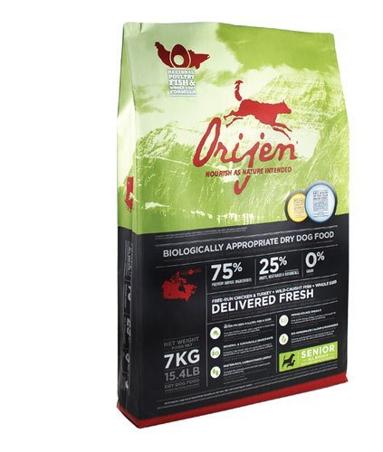

(Orijen, 2013)

Orijen Senior Dog is our product choice for Ryan Gosling and his dog George. This is because the product is available online through retailers but also in retail stores in New York City (Orijen, 2013). This makes the availability of this dog food ideal for Ryan Gosling, he can purchase it in whatever way he feels is best for him, making Orijen dog food an enticing choice for him. In addition, the product is featured on Amazon and is offered at a discounted rate giving Gosling multiple reasons to give this product a chance (Kerin, Hartley, Rudelius, & Skolnick, 2012, p. 58).

George is a fairly large dog, and is also 11 years old, so we feel as though Orijen’s Senior Dog foodwould be best for him. Older dogs like George are likely to experience problems with arthritis (Arthritis Foundation, 2013). There are numerous pictures of Gosling lifting George into his SUV after long walks- a sign that George could already be facing problems with his joints (Reporter, 2011). This makes the product a fantastic choice for Gosling, and it also makes it very enticing for him to purchase.

**Product SWOT**

|  |  |
| --- | --- |
| **Strengths**   * Orijen is a well-known brand of dog food, and consumers are increasingly aware of their good reputation for being highly nutritional. (Your Dog Guru, 2012). * This brand is considered to be a “biologically appropriate” dog food, which puts them far above other brands. ("Biologically appropriate" n.d.). * Varieties for different sizes of dog. ("Award-winning, biologically appropriate," n.d.). * Grain-free food is considered better for dogs, and all Orijen dry dog food is grain-free. (Preiser Animal Food, n.d.). * High ratings on dog food forums. (Sagman, 2013). * Support of local farmers increases consumer confidence in the organization. (Orijen, n.d.). | **Weaknesses**   * Sizes for adult dog only come in sizes 6.8kg and 13kg. (Orijen, n.d.). * Packaging does not differentiate Orijen from its competitors, as most competitors have the same shape and material of bagged dog food packaging. * Socially responsible mandates likely add cost to product. * Cost of 13kg bag is approximately $73 online, equating to $5.60 per kilogram. (Homes Alive Pet Centre, n.d.). * Grain-free competitor has a price of only $57.99 for 24 pounds (10.88 kg) equating to $5.33 per kilogram. (Petsmart, n.d.). |
| **Opportunities**   * Consumer demand for both grain-free dog food and high quality nutritious dog food is increasing (Headrick, 2011) * Consumer demand for natural ingredients is increasing while consumer spending is expected to rise as well (Government of Canada, 2011, pg. 2). * People are taking better care of their dogs, and an increase in demand for quality products has increased the lifespan of dogs, meaning people are purchasing dog food for longer spans of time, leading to a potential of more sales over a longer period of time with each customer (Government of Canada, 2011, pg. 9). * Dog food sales are projected to increase by 3% CAGR (Government of Canada, 2011, pg. 5). * Environmental and Ethical new dog food packaging launches recorded by the Government of Canada in 2010 only contain bags. There has not been significant innovation in dog food packaging. (Government of Canada, 2011, pg. 10). * Niche brands like Orijen that provide super premium products are thriving (Government of Canada, 2011, pg. 12). | **Threats**   * Recommendations of wet dog food over dry dog food could convert some consumers (Sagman, n.d.). * Competitors like Purina are marketing their eco-friendliness by having 90% recycled packaging, soy-based inks, and factories powered by solar energy (Government of Canada, 2011, pg.9). * Some competitors are changing packaging size to meet consumer demand for smaller sizes like Eagle Pack Original Adult Natural Dog Food, who recently released a 6lb bag option for customers. (Government of Canada, 2011, pg. 9). * Increased media regarding raw food diets and homemade diets for dog owners could deter buyers (Becker, 2010). |

In summary, Orijen is already in line with consumer demand in regards to natural, high quality food, and Orijen can continue to gain market share if it can align its branding and product’s image and material with that of consumer demand. If a 100% recyclable packaging and smaller buying options are created, Orijen will be able to continue to impress consumers and continue to exceed the quality of its competitors.

**Perceptual Map**

This is a perceptual map based on the nutrition and convenience factors of Orijen and its competitors; Purina, IAMS, and Pedigree. These factors were chosen because the main focus of Orijen’s makeover is offering convenient packaging, while providing a nutritious diet for dogs. Orijen has a reputation of being authentic and trustworthy which has contributed to Orijen becoming Canada’s award-winning pet food maker. Packaging for dog food typically ranges from 20 - 50 pounds, and we are looking to create a packaging solution that provides consumers with the option of carrying their dog food with them when they travel without having to bring the whole bag, all in a recyclable package.

Most Convenient

|  |  |
| --- | --- |
| Least Nutritious  Pedigree | New and Improved  Orijen  Most Nutritious |
| Purina  IAMS | Existing Orijen |

Least Convenient

Pedigree, Purina, and IAMS use grains, corn, and food coloring, which do not provide any nutritional value to dogs (Sagma, 2012a). Whole grain and corn is an ingredient that is used as filler food to make dogs feel bloated, this is not healthy for them (Sagma, 2012c). Purina, Pedigree, and IAMS are all plant-based dry dog foods. The key to proper nutritional value for dogs is providing a sufficient portion of protein (Sagma, 2012d). Pedigree and Purina both offer more convenience compared to IAMs because they sell smaller amounts by selling canned dog food.

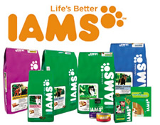

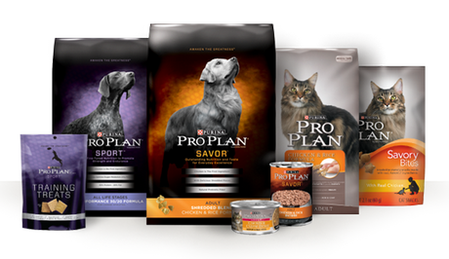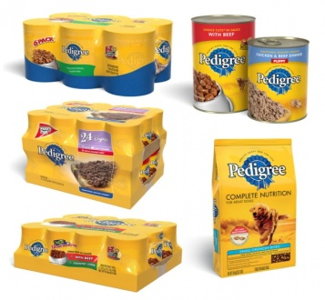

|  |  |  |  |  |
| --- | --- | --- | --- | --- |
| Figure 1 |  | Figure 2 |  | Figure 3 |

Orijen is one of the top manufacturers of pet food, focusing on providing very high nutrition for dogs everywhere. Orijen’s competitors provide very little convenience when it comes to dry dog food because they are generally always sold only in large amounts.

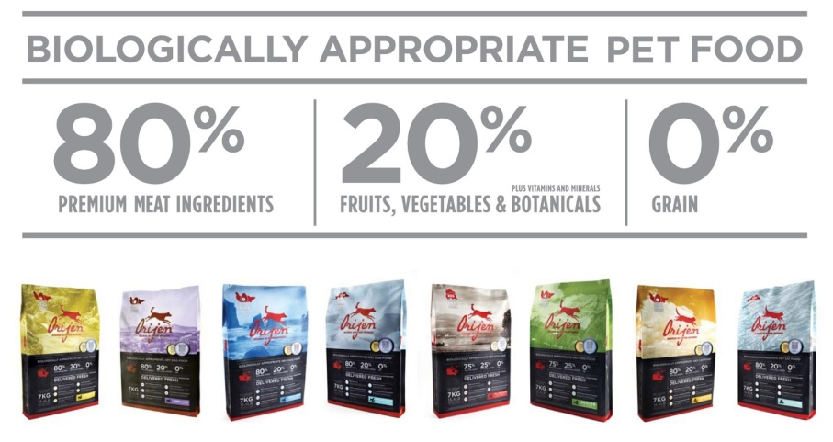

Figure 4

We have decided to introduce a new idea for the existing Orijen dog food by making a smaller package that is environmentally friendly and re-usable by consumers. The goal of this reinvented packaging is to make it easier for dog owners to bring nutritious dog food with them when they travel with their dogs.

**Pricing Strategy**

Orijen is only sold at specialty pet shops and veterinarian facilities. The quality of Orijen’s dog food is extremely high because the manufacturing of it is not outsourced, and they also use fresh regional ingredients. The pricing strategy we chose is price skimming, because Orijen has a status that is reputably high ("Award-winning, biologically appropriate," n.d.). Fresh protein like poultry, fish, and red meat are delivered to the Orijen facility every day, allowing them to maintain their promise of being preservative-free ("Biologically appropriate" n.d.).

If Orijen were to expand their market to sell in local convenience and grocery stores, they would be able to sell their product at a high price still. Many of their customers complain that it is difficult to find the product, so they are more willing to try a competitor’s product. This can be resolved by selling Orijen dog food in local department stores, as it would likely be more convenient for customers and fit some of the needs of our target consumer market. Orijen offers one of the most nutritious dog foods on the market, and many customers are willing to pay more to keep their dogs at optimal health.

Our Manufacturer’s Suggested Retail Price is $29.99, which is also an odd-even price. This allows customers to see the price as “something over $20” rather than “about $30”. This is a good price to sell the product because the package is reusable, and it comes with dog food when you first purchase it. The product will give the impression of good value and a deal, but not cheap either at the same time.

**Packaging Re-Design**

ORIGAMI by Origen has been created as a travel and eco-friendly packaging option to differentiate Orijen from its competitors. The simple and minimalistic packaging and coloring reflects our vision of being eco-friendly with white, green, and recycled cardboard and paper. This allows the customer to envision the product as eco-friendly and healthy for their dog. The labeling clearly communicates to the consumer its features by way of the travel symbols, recycling symbol, and the dish + container symbol that indicates that the packaging also includes a bowl as part of the packaging. The “ORIGAMI” text and the green dog logo were designed so that consumers would associate it with actual origami. We chose to use origami as part of our brand message because it implies recyclability due to the fact that it is made of paper, causing recyclability to come as a subliminal message. The instructions contained inside clearly detail the use of the cardboard insert that allows the user to “lock up” the bulk of the food while the dog eats out of the other portion of the box. Included inside is a 100% recyclable scoop that allows the user to properly measure out portions of food. Under mass production, the final retail version of our box would be able to be folded into the shape without the use of adhesives, also adding to our reasoning to re-brand the product as ORIGAMI. The packaging itself is also re-usable after the dog food has all been used up. Discounted refills could be given to customers who bring their old ORIMAGI boxes and purchase more Orijen dog food from our brick and motor retailers. This adds to the longevity and the eco-friendliness of the product and makes it more desirable.

**Before**

**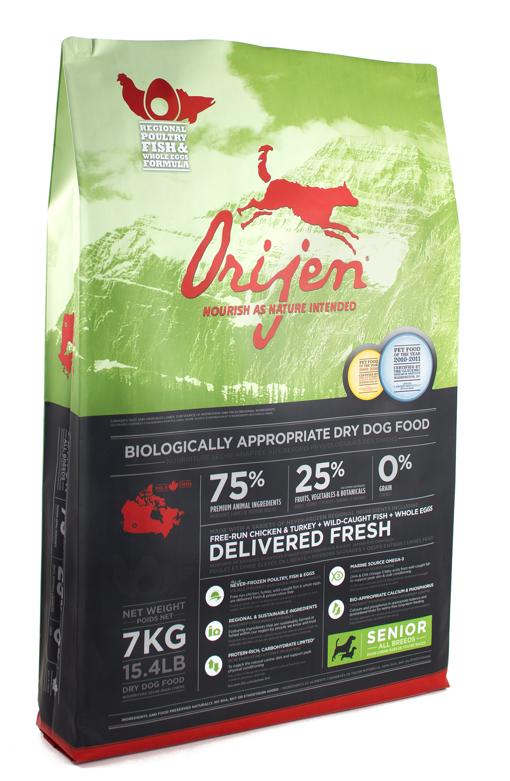**

**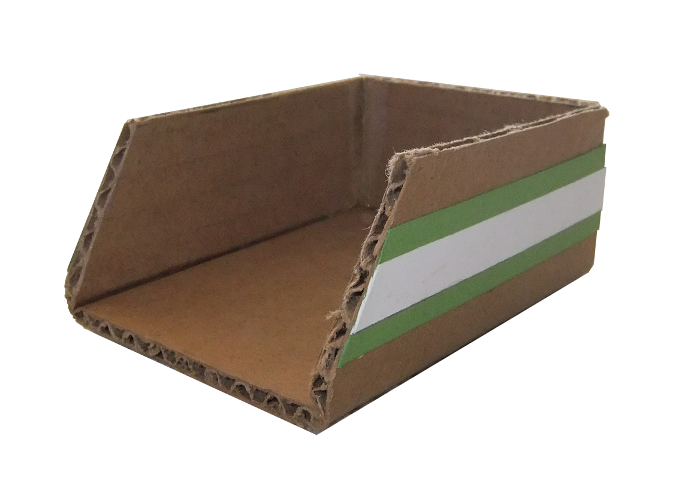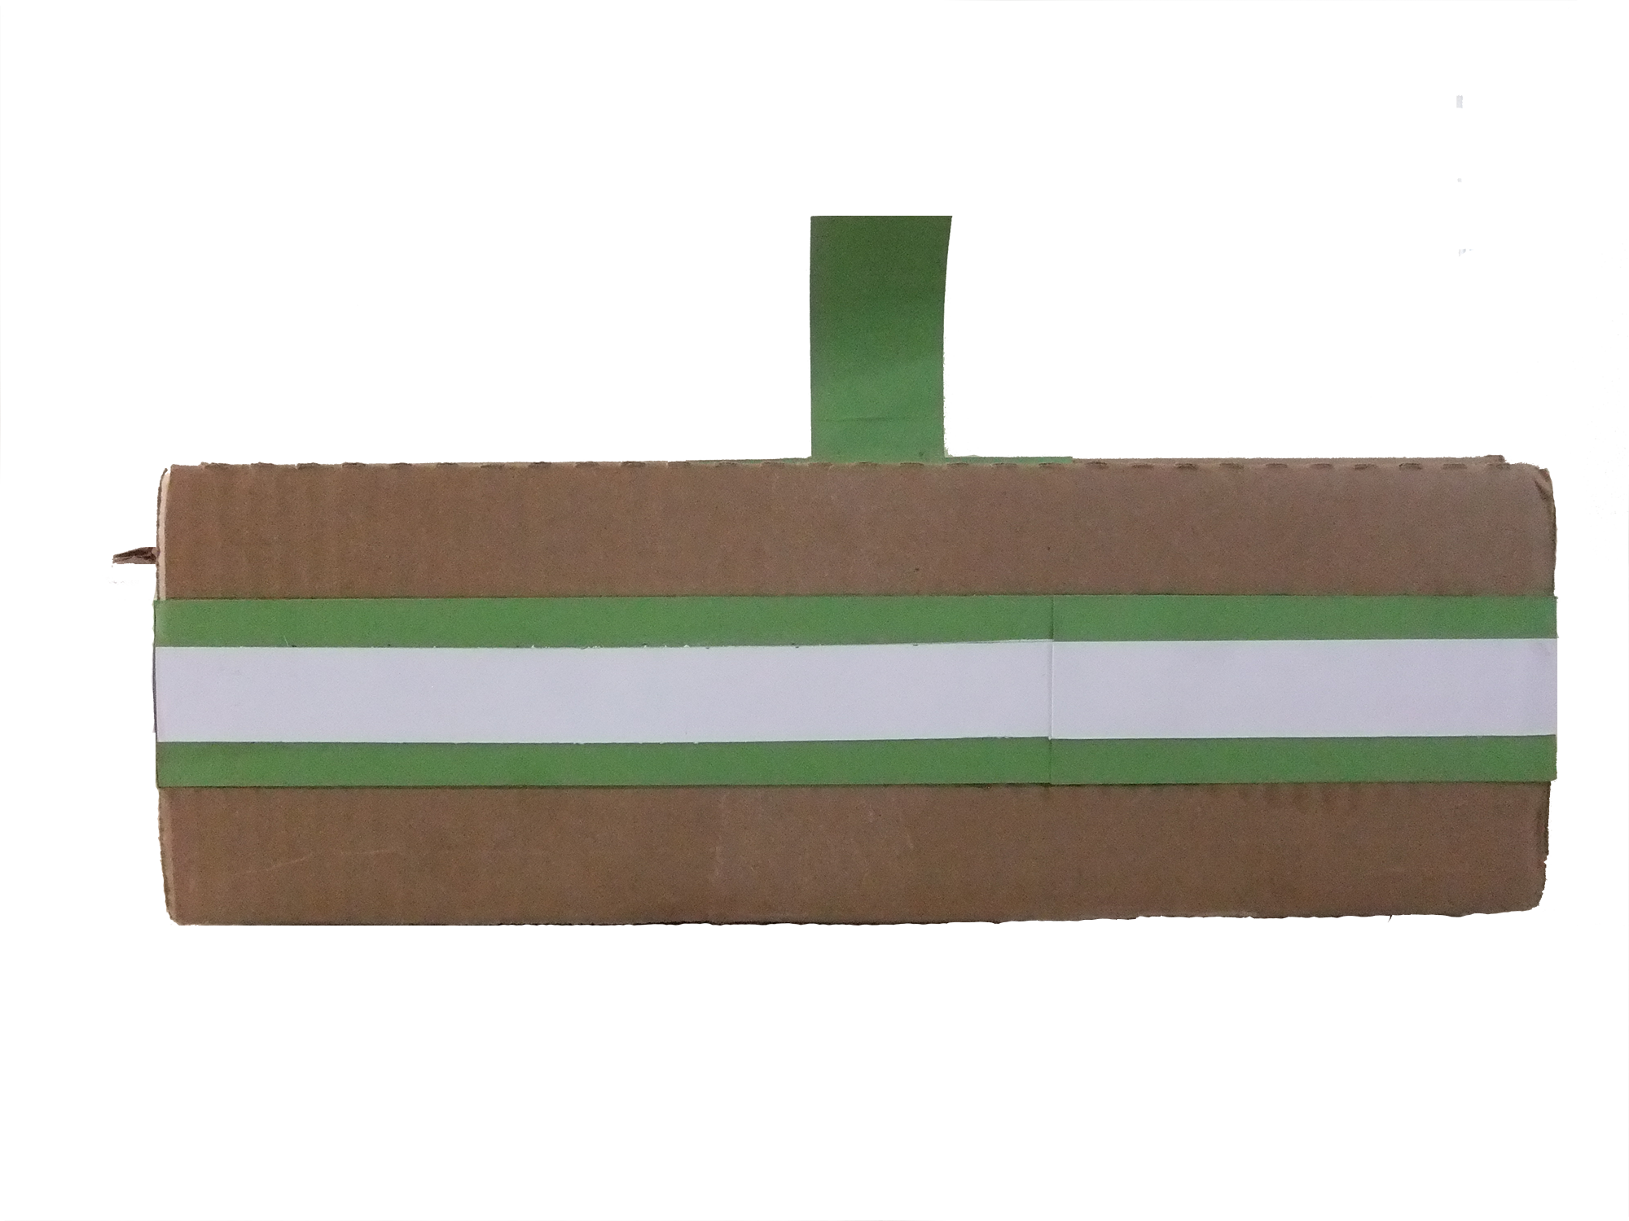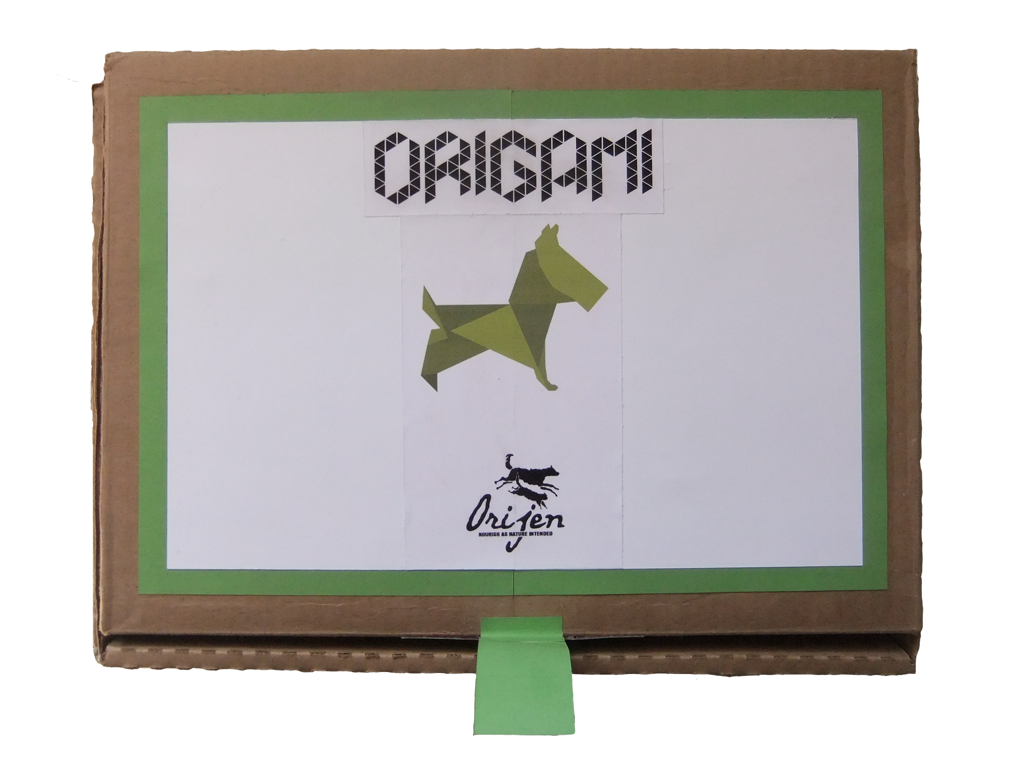After**

**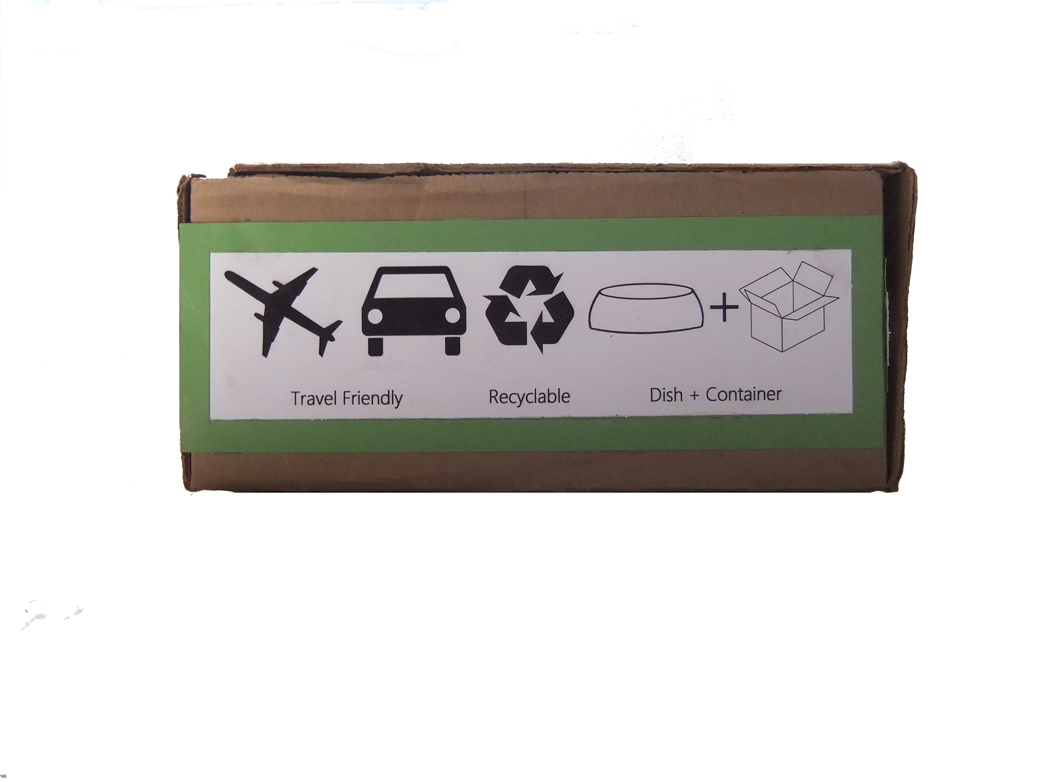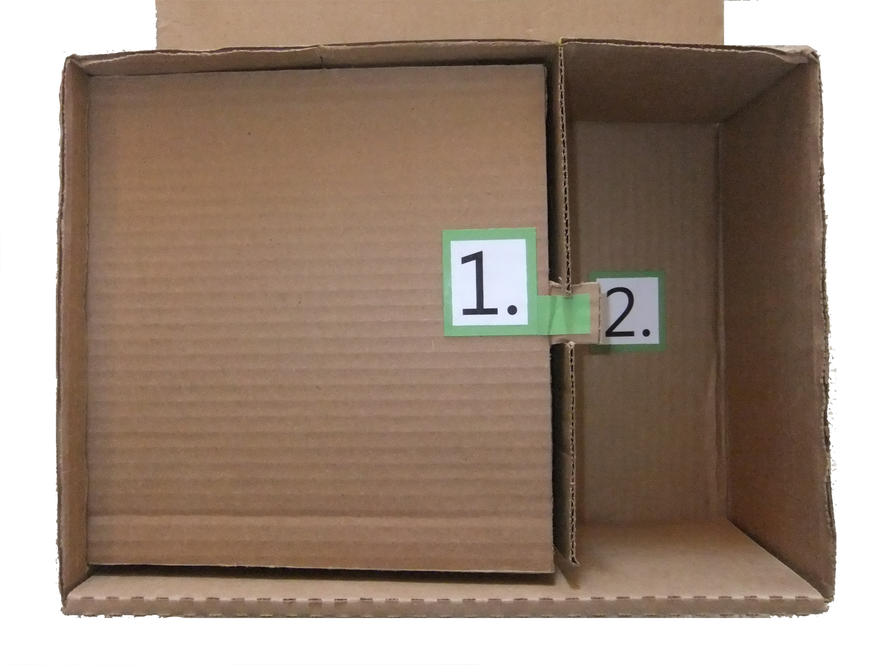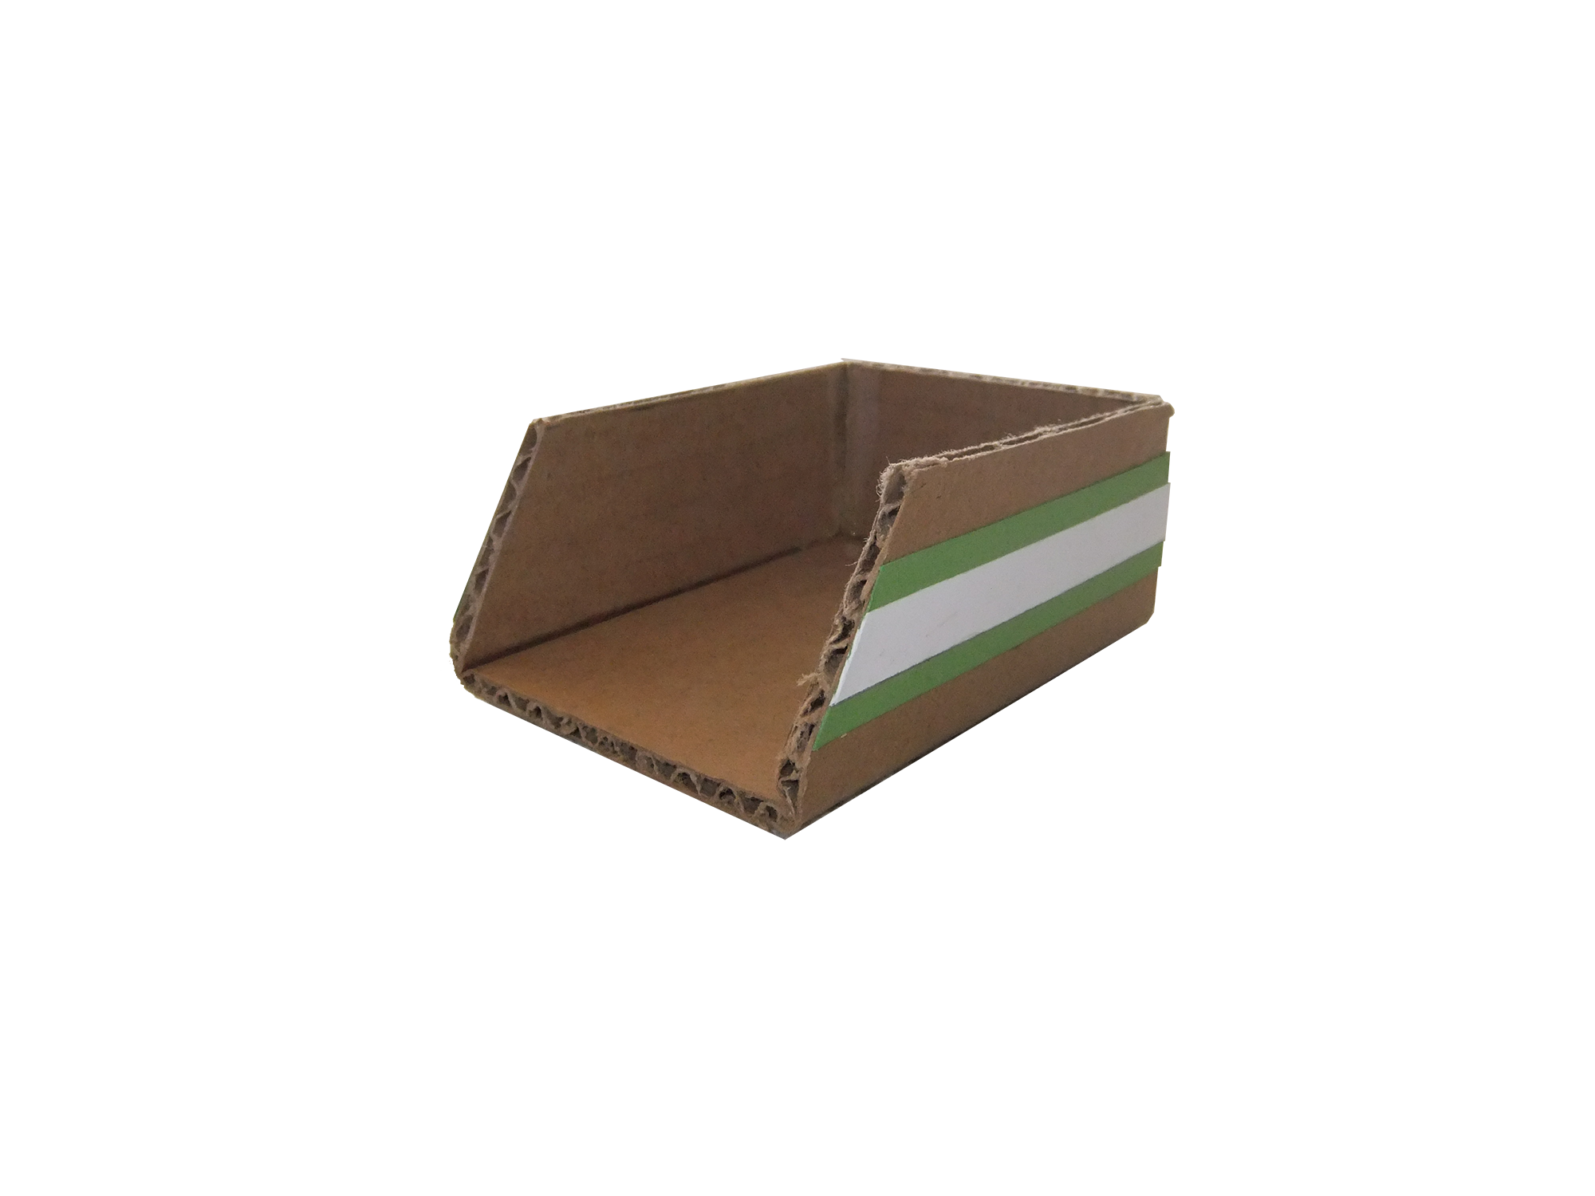**

**Distribution Strategy**

**Which new retail channel (bricks & mortar retailer, not online) have you chosen and why?**

Orijen is a trusted brand and they only provide supply of their pet food to those who are deeply concerned about the well being of animals, and those who offer support by providing quality advice and great service (Orijen SL). Choosing a suitable retailer was relatively easy when considering these conditions. Petland stands out among the rest by being known for their role with Pets For Life Foundation, Adopt A Pet, and Pets For A Life Time (Petland A). With this partnership we would have full access to stores nationwide, and we would be able to execute our distribution strategy to the targeted markets in retail locations.

**Explain your strategy for designing a point-of-purchase promotion/display concept for this retailer**

Petland would have coupons that will give each customer $15 off ORIGAMI on every purchase for a limited time. Customers best respond to “dollars-off discounts” instead of “percentage discounts”, so we have decided that this drastic sale promotion could be highly beneficial to the market penetration and consumer awareness of the product (Reece a). Establishing a discount seen as enticing will attract new customers that have been purchasing from our competitors (Reece b). We will be obtaining basic information like a name, address, and email, but we will also include “where are you going with your dog”, and “where would you like to travel with your dog”. This is going to become valuable information for marketing plans in the future, and we’ll also be able to follow up with our customers (Reece c). The sign-ups for the coupon will also have a print advertisement on the back of it to promote our #dogventures hashtag which will further promote the new ORIGAMI brand to consumers through social media.

**Promotion Strategy**

**Describe your creative strategy; what’s the thinking behind the creative approach you’ve decided to use for your promotions?**

In the creative approach we wanted to target the “For the Dog on the Go” owner, as we have found that most major airlines accommodate about 500 dogs per day. Meeting the demand for dog-friendly travel items is a high priority (Pawnation a). We wanted to impact the dog’s active life style, by promoting “Home is where the Food is” approach by bringing the taste of home where ever dogs are travelling alongside their owners. A picture can say a thousand words, and through social media it can reach millions of people with very little cost. Launching our previously mentioned #dogventures Instagram campaign that features a trip incentive is a great approach considering 40 million pictures are uploaded every day (Instagram a).

**Which advertising appeal have you selected and, more importantly, why?**

The dog traveling industry is currently valued at around 27 million dollars a year (Pawnation b). Our customer profile showed that our target market is an active traveler that takes their dog everywhere, especially on adventures. We knew that we needed something for the on-the-go dog owner. ORIGAMI brings the simplicity of your dog bowl and your dog’s food into one simple and easy to use package that can be taken with you very easily.

**Explain your thinking behind your choice of specific print publication for your Print Advertisement; don’t forget to say which publication it is.**

For our print publication we chose to go with Modern Dog and FIDO Friendly. Modern Dog is a magazine that is distributed amongst dog lovers, which focuses on dog-friendly travel destinations, budget buys, and how to build a better bond with your dog (Modern Dog). FIDO Friendly is known as the “Travel & Lifestyle Magazine for You & Your Dog.” Having wellness tips, training advice, and unique and exotic location getaways (FIDO).

**Explain your ideal location(s) strategy for your Out-of-Home Advertisement; what is it about the kind of location you’ve chosen that will make this promotion work?**

When we were looking at appropriate locations, we came to realize that we needed to place our ads where they would be able to reach our targeted audience together. Being able to establish a presence in dog parks and dog friendly neighborhoods by placing billboards and posters would put our product right in front of our targeted audience (Dogfriendly).

**Describe your Social Media concept and who it will attract. Are you trying to interest your customer or someone who will influence them? Remember, social media promotional strategies need to give your audience a reason to care and take time out of their busy lives to interact with your message and social community.**

We will be infiltrating the market by launching a mass media program that captures master and canine on one of their many adventures (Toothman). We will be doing a trip incentive to invite current customers and new customers to the table. Users will simply take a picture of themselves with their dog and hashtag #dogventures for a chance to win a desirable trip for them and their dog with Orijen. Instagram has an average of 40 million picture uploads per day, 8500 Likes per second, and 100 million monthly active users (Instagram b). The social media power behind such a campaign can be seen once before in video format, and as it started as something small it exploded into a worldwide campaign (Worlds G). With this specific plan of action we will be able to influence both our current customers, and influence their followers through a massive web affect (Isaksson).

**References**

Agency, Q. (2012, October 11). *Avril Lavigne, Justin Bieber and Ryan Gosling are related: Report | Celebrities | Entertainment | Toronto Sun*. Retrieved February 6, 2013, from TorontoSun.com: http://www.torontosun.com/2012/10/11/avril-lavigne-justin-bieber-and-ryan-gosling-are-related-report

Arthritis Foundation. (2013, February 11). *Arthritis in Dogs l Canine Arthritis l Treatment l Arthritis Dog Walks*. Retrieved February 11, 2013, from Arthritis Foundation: http://www.arthritis.org/conditions-treatments/disease-center/arthritis-dogs/

*Aspatial Peripherality, Innovation And The Rural Economy (AsPIRE)*. (n.d.). Retrieved August 9, 2010, from Scottish Agricultural College: <http://www.sac.ac.uk/research/projects/landeconomy/featured/aspire/>

*Award-winning, biologically appropriate pet foods*. (n.d.). Retrieved March 23, 2013 from <http://orijen.ca/products>

Becker, D. K. (2010). *13 pet foods – ranked from great to disastrous…*. Retrieved March 23, 2013 from http://healthypets.mercola.com/sites/healthypets/archive/2010/07/21/13-pet-foods-ranked-from-great-to-disastrous.aspx

*Biologically appropriate- a new class of pet foods*. (n.d.). Retrieved March 23, 2013 from http://orijen.ca/about\_orijen

Chiarella, T. (2011, August 9). *Ryan Gosling Interview – Ryan Gosling Drive and Crazy, Stupid, Love - Esquire*. Retrieved February 6, 2013, from Esquire: <http://www.esquire.com/features/ryan-gosling-interview-0911-3>

Coupon: (Reece a) Thom Reece. (2013) Business Kow How website. Retrieved March 25, 2013, from <http://www.businessknowhow.com/marketing/couponing.htm>

Coupon: (Reece b) Thom Reece. (2013) Business Kow How website. Retrieved March 25, 2013, from <http://www.businessknowhow.com/marketing/couponing.htm>

Coupon: (Reece c) Thom Reece. (2013) Business Kow How website. Retrieved March 25, 2013, from <http://www.businessknowhow.com/marketing/couponing.htm>

Dog friendly destinations: (Dogfriendly) dog friendly. (2013) dogfriendly website. Retrieved March 25, 2013, from http://dogfriendly.com/

*Facebook - Ryan Gosling*. (n.d.). Retrieved February 11, 2013, from Facebook: <https://www.facebook.com/pages/Ryan-Gosling/10104687636>

*Figure 1*. Cooper, T. (2009). Pedigree Dog Food Packaging. Retrieved March 28, 2013 from <http://features.cgsociety.org/newgallerycrits/g72/358072/358072_1233679015_submedium.jpg>

*Figure 2*. Photograph of Iams Dog Food Packing. Retrieved March 28, 2013 from  
<http://www.itchmo.com/wp-content/uploads/2007/08/iams1.jpg>

*Figure 3*. Sagman, M. (2012). Photograph of Dog Packaging for Purina. Retrieved March 28, 2013 from <http://cdn.dogfoodadvisor.com/wp-content/uploads/2013/01/new-purina-pro-plan-460.png>

*Figure 4*. Photograph of Orijen Dog Food Packaging. Retrieved March 29, 2013 from <http://doggiefood.files.wordpress.com/2010/11/orijen-80-20.jpg>

Gosling, R. (2011, July 20). Ryan Gosling 2011.07.20. (J. Fallon, Interviewer) Retrieved from http://www.youtube.com/watch?v=4plEJMopitg

Gosling, R. (2011, September 26). Ryan Gosling interview. (J. Leno, Interviewer) Retrieved from http://www.youtube.com/watch?v=m44goj3hVZE

Gosling, R. (2011, July 1). Ryan Gosling's Big Gift. (E. Degeneres, Interviewer)

Government of Canada. (2011). *Consumer trends*. Retrieved March 24, 2013 from <http://publications.gc.ca/collections/collection_2011/agr/A74-1-17-2011-eng.pdf>

Headrick, D. (2011). *Healthy demand*. Retrieved March 23, 2013 from <http://www.petbusiness.com/articles/2011-08-01/Healthy-Demand>

Homes Alive Pet Centre. (n.d.). *Dogs*. Retrieved March 23, 2013 from <http://www.homesalive.ca/orijen-adult-dog-food.html>

Hopwood, J. C. (n.d.). *Ryan Gosling - Biography*. Retrieved February 6, 2013, from IMDb: http://www.imdb.com/name/nm0331516/bio

Jones, E. (2013, January 11). *Ryan Gosling tells all about the love of his life (his dog, George) - Features - Films - The Independent*. Retrieved February 11, 2013, from The Independant: http://www.independent.co.uk/arts-entertainment/films/features/ryan-gosling-tells-all-about-the-love-of-his-life-his-dog-george-8448580.html

Jung, H. (2011, July 28). *Ryan Gosling and His Dog George (Photos) : People.com*. Retrieved from peoplepets.com: http://www.peoplepets.com/people/pets/gallery/0,,20513463,00.html#20993900

Kerin, R. A., Hartley, S. W., Rudelius, W. C., & Skolnick, H. (2012). *Marketing: The Core Third Canadian Edition.* Leanna MacLean.

Lawrence, W. (2008, March 9). *Ryan Gosling: meet the star of 'Lars and the Real Girl' - Telegraph*. Retrieved February 6, 2013, from The Telegraph: <http://www.telegraph.co.uk/culture/film/3671738/Ryan-Gosling-meet-the-star-of-Lars-and-the-Real-Girl.html>

Magazine: (FIDO) FIDO Friendly (n.d) FIDO Friendly website. Retrieved March 25, 2013 from <http://www.fidofriendly.com>

Magazine: (Modern Dog) Modern Dog (n.d) Modern Dog website. Retrieved March 25, 2013, from <https://moderndogmagazine.com/dog-life>

Mandora, S. (2012). Healthy Dog Food Ratings. *Buzzle.* Retrieved March 27, 2013, from <http://www.buzzle.com/articles/healthy-dog-food-ratings.html>

Nestlé Purina PetCare Canada. (2012). *Puppies | How Much Is Enough?* Retrieved Febriary 6, 2013, from Purina: http://www.purina.ca/mypuppy/article.aspx?article\_id=662

Nestlé Purina PetCare. (n.d.). *Where to Buy Pro Plan® Pet Food - Purina® Pro Plan®*. Retrieved February 6, 2013, from Purina Pro Plan: <http://www.proplan.com/where-to-buy/>

Orijen. (n.d.). *A diversity of fruits and vegetables*. Retrieved March 23, 2013 from <http://orijen.ca/about_orijen/regional>

Orijen. (n.d.). *Whole prey*. Retrieved March 23, 2013 from <http://orijen.ca/wholeprey/ORIDRYWEBBRO2012.pdf>

Orijen. (2013, March 16). *New Your Store Listing*. Retrieved from Orijen.ca: http://orijen.ca/orijen/storeLocator/NewYorkStoreListing.aspx

Orijen. (2013, March 16). *Orijen - Sernior Dog*. Retrieved from Orijen.ca: <http://orijen.ca/products/senior_dog>

Petsmart. (n.d.). *Blue™ freedom grain-free natural chicken recipe puppy food*. Retrieved March 23, 2013 from http://www.petsmart.com/product/index.jsp?productId=12152261&lmdn=Nutrition Option&f=PAD/psNotAvailInCA/No

*Phillips, Amy*. (2009, January 11). Retrieved February 6, 2013, from Pitchfork: <http://pitchfork.com/news/34432-meet-dead-mans-bones-ryan-gosling-and-zach-shields/>

Preiser Animal Food. (n.d.). *" why grain free food is good for your pet"*. Retrieved March 23, 2013 from http://preiseranimalhospital.com/custom\_content/c\_177605\_\_why\_grain\_free\_food\_is\_good\_for\_your\_pe.html

Purina. (2013, February 11). *PURINA ONE® SMARTBlend™ Lamb and Rice Formula*. Retrieved February 11, 2013, from Purina.ca: http://www.purina.ca/products/dogs/purina-one/purina-one-adult-lamb-and-rice.aspx

Purina. (2013, February 11). *PURINA ONE® SMARTBlend™ Large Breed Formula*. Retrieved February 11, 2013, from Purina.ca: http://www.purina.ca/products/dogs/purina-one/purina-one-large-breed-adult.aspx

Reporter, D. M. (2011, September 19). *Ryan Gosling must have Crazy, Stupid, Love for his massive dog George | Mail Online*. Retrieved February 11, 2013, from DailyMail.co.uk: <http://www.dailymail.co.uk/tvshowbiz/article-2038845/Ryan-Gosling-Crazy-Stupid-Love-massive-dog-George.html#axzz2KcMuSgJn>

Retail identity: (Orijen SL) Orijen. (n.d) Orijen website. Retrieved, March 25, 2013, from <http://orijen.ca/orijen/storeLocator/>

Retail channel: (Petland A) Petland. (n.d) Petland website. Retrieved, March 25, 2013, from <http://stores.petland.ca/CommunityService/PetsForALifetime.htm>

Retail channel: (Petland A) Petland. (n.d) Petland website. Retrieved, March 25, 2013, from http://stores.petland.ca/CommunityService/PetsForALifetime.htm

*Ryan Gosling (RyanGosling) on Twitter*. (n.d.). Retrieved February 11, 2013, from Twitter: https://twitter.com/RyanGosling

*Ryan Gosling Biography - Facts, Birthday, Life Story - Biography.com*. (n.d.). Retrieved February 6, 2013, from The Biography Channel Website: www.biography.com/people/ryan-gosling-212045?page=1.

*Ryan Gosling Net Worth | Celebrity Net Worth*. (n.d.). Retrieved February 6, 2013, from GetNetWorth.com: http://www.getnetworth.com/ryan-gosling-net-worth/

*Ryan Gosling, Eva Mendes: All About Their Romance : People.com*. (2013 , January 9). Retrieved from People.com: http://www.people.com/people/article/0,,20662666,00.html

*Ryan Gosling's Charity Work, Events and Causes | Look To The Stars*. (n.d.). Retrieved February 7, 2013, from Look To The Stars | The World of Celebrity Giving: <http://www.looktothestars.org/celebrity/ryan-gosling>

Sagman, M. (n.d.). *Canned or dry dog food — what’s the better choice?*. Retrieved March 23, 2013 from <http://www.dogfoodadvisor.com/choosing-dog-food/canned-or-dry-dog-food/>

Sagman, M. (2012a). Iams Proactive Health(Dry). *Dog Food Advisor.* Retrieved March 29, 2013, from <http://www.dogfoodadvisor.com/dog-food-reviews/iams-proactive-health-adult/>

Sagman, M. (2012b). Orijen Dog Food(Dry). *Dog Food Advisor.* Retrieved March 29, 2013, from <http://www.dogfoodadvisor.com/dog-food-reviews/orijen-dog-food-adult/>

Sagman, M. (2012c). Pedigree Dog Food(Dry). *Dog Food Advisor.* Retrieved March 29, 2013, from <http://www.dogfoodadvisor.com/dog-food-reviews/pedigree-dog-food-dry>

Sagman, M. (2012d). Purina Dog Chow(Dry). *Dog Food Advisor.* Retrieved March 29, 2013, from http://www.dogfoodadvisor.com/dog-food-reviews/purina-dog-chow/

Sagman, M. (2013). *Orijen puppy (dry)*. Retrieved March 23, 2013 from <http://www.dogfoodadvisor.com/dog-food-reviews/orijen-dog-food-puppy/>

Social media: (Instagram) Instagram. (n.d) Instagram website. Retrieved March 25, 2013, from <http://instagram.com/press/>

Social media: (Isaksson) Peter Isaksson. (n.d) slide share website. Retrieved March 25, 2013, from <http://www.slideshare.net/Webbanalys/the-chain-reaction-within-social-media>

Social media: (Worlds G) Carlos Merigo. (June 5, 2009) YouTube website. Retrieved March 25, 2013, from http://www.youtube.com/watch?v=SI-rsong4xs

Solomon, M. M. (2009). *Marketing: real people, real decisions* (3rd Canadian Edition ed.). Toronto: Pearson Prentice Hall.

Travel with dog: (Toothman) Jessica Toothman & Heather Kolich. (n.d) Animal Planet website. Retrieved. March 25, 2013, from http://animals.howstuffworks.com/pets/pet-travel/5-pet-friendly-vacation-spots.htm

Traveling dog industry: (Pawnation) The Jet Set Pets. (July 13, 2012) pawnation website. Retrieved, March 25, 2013, from http://www.pawnation.com/2012/07/13/smartmoney-recognizes-more-people-traveling-with-pets/

Your Dog Guru. (2012). *Dog nutrition – what dog food is best? orijen!*. Retrieved March 23, 2013 from <http://www.yourdogguru.com/dog-nutrition-dog-food-best-orijen/>

Wilson, G. (2011, September 27). *Ryan Gosling Wears Burberry Prorsum Suit Twice In One Month, Tells Jay Leno He Doesn’t Care | MTV Style*. Retrieved from MTV Style: http://style.mtv.com/2011/09/27/ryan-gosling-jay-leno/

**A) MARKETING STRATEGY BRIEF**

|  |  |  |  |  |  |  |
| --- | --- | --- | --- | --- | --- | --- |
| **EXPECTATIONS** | Potential marks | **Actual marks** | Exceeds | Meets | Below | Un-acceptable |
| **Research**   * Relevant and credible sources * Fully and correctly cited and referenced\* * Profile updated (if required from Assignment #1) * Clearly informs Marketing Strategy * At least 5 high-quality secondary research sources\*\* | **10** |  | 10 | 7-9 | 5-6 | 0-4 |
| **Product SWOT**   * All matrix elements complete and accurate * Information is timely and relevant to situation * Provides insight for marketing plan decisions | **10** |  | 10 | 7-9 | 5-6 | 0-4 |
| **Perceptual Positioning**   * Thoughtful choice of relevant competing products * Axis labels appropriate for target customer, competition * Appropriate positioning based on sound research * Photos or links for all competing products | **10** |  | 10 | 7-9 | 5-6 | 0-4 |
| **Pricing**   * Competition’s prices complete and accurate * Appropriate pricing strategy for positioning * MRSP suitable for pricing strategy and retailer | **3** |  | 3 | 2 | 1 | 0 |
| **Packaging**   * Design clearly reflects re-positioning strategy * Visibly differentiates product from competition * Demonstrates thoughtful attention to detail * All design decisions linked to earlier research | **10** |  | 10 | 7-9 | 5-6 | 0-4 |
| **Distribution Strategy**   * Retailer choice suitable and fully-justified * POP promotion/display appropriate for retailer and product positioning | **5** |  | 5 | 4 | 2-3 | 0-1 |
| **Promotion Strategy**   * Unique & thoughtful creative strategy * Advertising strategy a good choice for target customer and product’s new positioning * Social Media concept effective & complete | **7** |  | 7 | 5-6 | 3-4 | 0-2 |
| **Overall Professionalism & Depth**   * Professional marketing document appearance * All required sections included and complete * Demonstrates overall logic and flow between sections | **5** |  | 5 | 4 | 2-3 | 0-1 |
| **Correctness Level**   * No grammatical, spelling or punctuation errors | **5** |  | 5 | 4 | 2-3 | 0-1 |
| **TOTAL:** | **65** |  |  |  |  |  |

***\*NOTE:*** *Assignment will not be graded if citations and references are not included. (Academic Misconduct)*

*If there are no citations you will receive a grade of zero and a warning for Academic Misconduct.*

*If references are also absent, you will receive a grade of zero and an Academic Misconduct report will be filed.*

*\*\* In addition to those already used for the Customer Profile from Assignment Part 1*

**B) TEAM PROJECT− POSTER & PACKAGING DAY**

**DATE: \_\_\_\_\_\_\_\_\_\_\_\_\_\_\_\_\_\_\_\_\_\_\_\_\_\_\_\_\_\_\_\_\_\_ MKTG 2150 - \_\_\_\_\_\_\_\_**

**PROJECT OF TEAM: \_\_\_\_\_\_\_\_\_\_\_\_\_\_\_\_\_\_\_\_\_\_\_\_\_\_\_\_\_\_\_\_\_\_\_\_\_\_\_\_\_\_\_\_\_\_\_\_\_\_\_\_\_\_\_\_\_\_\_\_\_\_\_\_\_**

Unacceptable Poor Fair Good V.Good Excellent!

0 1 2 3 4 5

STRATEGY

* Customer needs/wants clearly communicated 🞎 🞎 🞎 🞎 🞎 🞎
* Retailer choice & POP design suitable for product 🞎 🞎 🞎 🞎 🞎 🞎

NEW PACKAGING CONCEPT

* Design, positioning & customer well-matched 🞎 🞎 🞎 🞎 🞎 🞎
* Concept has potential to be used in real-life 🞎 🞎 🞎 🞎 🞎 🞎

PROMOTIONS

* Ads in harmony, but well-adapted to each medium 🞎 🞎 🞎 🞎 🞎 🞎
* Advertising copy thoughtfully crafted & complete 🞎 🞎 🞎 🞎 🞎 🞎
* Social Media concept likely to attract targeted fans 🞎 🞎 🞎 🞎 🞎 🞎

SUBTOTALS: \_\_\_ \_\_\_ \_\_\_ \_\_\_ \_\_\_ \_\_\_

TOTAL: \_\_\_\_ / 35 **= CLASS RANKING: #\_\_\_\_ OF \_\_\_\_ TEAMS**

PROFESSIONALISM YES NO

* Questions answered fully & accurately 🞎 🞎
* Poster artwork shows full attention to detail 🞎 🞎
* Good balance between analysis & creativity 🞎 🞎
* All required elements included 🞎 🞎
* Respectful appearance and tone 🞎 🞎

**EVALUATED BY TEAM OR JUDGE: \_\_\_\_\_\_\_\_\_\_\_\_\_\_\_\_\_\_\_\_\_\_\_\_\_\_\_\_\_\_\_\_\_\_\_\_\_\_\_\_\_\_\_\_\_\_\_\_\_\_**

*For professor’s use only:*

Marketing Strategy Brief Grade: \_\_\_\_\_ / 65

Professor’s Poster Grade: \_\_\_\_\_ / 35

Any Professionalism Deduction \_\_\_\_\_ (−)

Any Class Ranking Bonus \_\_\_\_\_ (+)

\_\_\_\_\_\_\_\_\_\_\_\_\_\_\_\_\_\_\_\_\_\_\_\_\_\_\_\_\_\_\_\_\_\_\_\_\_\_

**TOTAL ASSIGNMENT GRADE: \_\_\_\_\_ / 100**

Class Rank: # \_\_\_\_\_\_\_\_\_

* Rank #1 = + 5%
* Rank #2 = + 3%
* Rank #3 = +1%